AI-Based Smart Chatbot Platform

NAME : DILLI GANESH B CYBERNAUT PROJECT INTERN MONTH 3 PROJECT 1 (TEAM 11)

PROJECT DESCRIPTION
The AI-Based Smart Chatbot Platform is a web-oriented application developed to assist organizations in building and managing intelligent chatbots through a centralized system. The platform focuses on simplifying chatbot creation, training, and interaction handling without requiring deep technical expertise. It enables automated communication, improves response efficiency, and supports scalable deployment for various service-based applications.
The system is designed to manage the complete chatbot lifecycle, from initial setup and training to real-time user interaction and performance tracking. By integrating artificial intelligence techniques with a modular web architecture, the platform ensures flexibility, efficiency, and ease of use.

PROBLEM STATEMENT
Many organizations face challenges in handling large volumes of user queries using traditional support systems. Common issues include: - Increased workload on human support teams - Delays in responding to user requests - Repetitive and predictable customer queries - Lack of automation and analytical insights
These limitations reduce operational efficiency and negatively impact user satisfaction.

PROPOSED SOLUTION
The proposed AI-Based Smart Chatbot Platform provides an automated solution to address these challenges by: - Enabling quick chatbot setup through a centralized interface - Allowing chatbot training using intent-based data - Automating responses to frequently asked questions - Providing analytics to monitor chatbot performance - Supporting scalable and secure deployment

TECHNOLOGY USED
- Programming Language: Python
- Backend Framework: Flask
- Frontend Technologies: HTML, CSS, JavaScript
- AI / NLP Approach: Intent-based Natural Language Processing
- Database: SQLite
- API Architecture: RESTful APIs
- Development Tools: VS Code, Git

FEATURES
1. CENTRALIZED DASHBOARD
- Manage multiple chatbots from a single interface
- Create, update, and remove chatbots
- Test chatbot responses in real time
- View usage statistics and logs
2. CHATBOT CONFIGURATION
- Define chatbot identity and purpose
- Customize predefined responses
- Add frequently asked questions
- Control chatbot behavior using training data
3. NATURAL LANGUAGE PROCESSING
- Interpret user input in natural language
- Identify user intent using keyword matching
- Generate suitable responses based on training data
4. TRAINING MODULE
- Add patterns and responses for chatbot learning
- Improve chatbot accuracy through retraining
- Maintain separate training data for each chatbot
5. DEPLOYMENT SUPPORT
- Web-based chatbot interaction
- API support for external integration
- Scalable backend architecture
6. MONITORING AND ANALYTICS
- Track number of conversations
- Store and display chat history
- Analyze chatbot usage trends
7. SECURITY
- Controlled API access
- Secure data storage
- Basic authentication mechanisms

SYSTEM FLOW
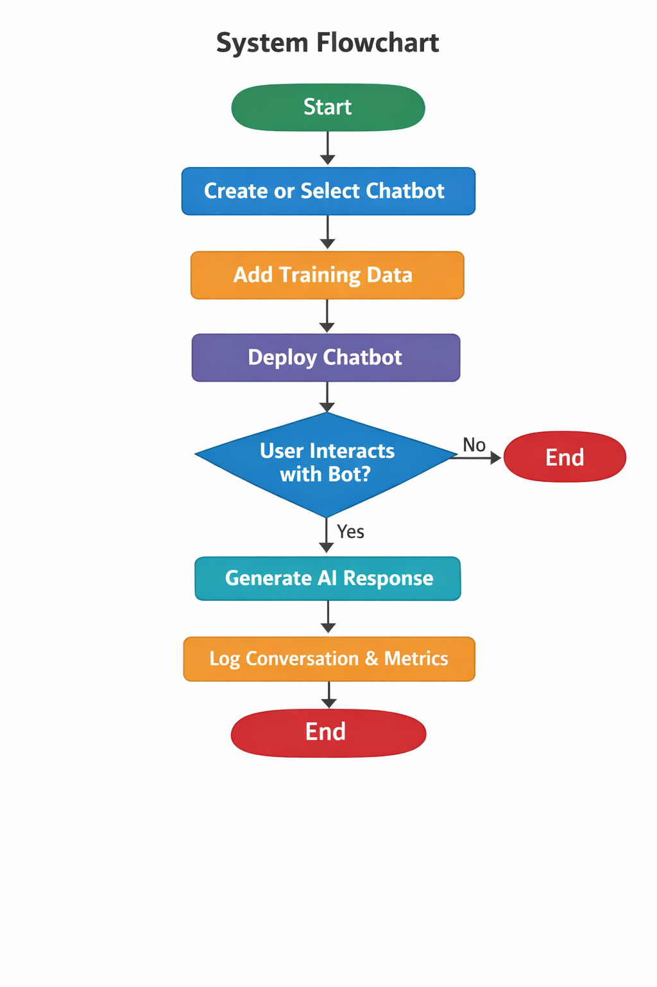
OUTCOMES AND BENEFITS
- Reduced dependency on human support staff
- Faster and consistent responses to users
- Improved user engagement
- Centralized monitoring and management
- Cost-effective communication automation

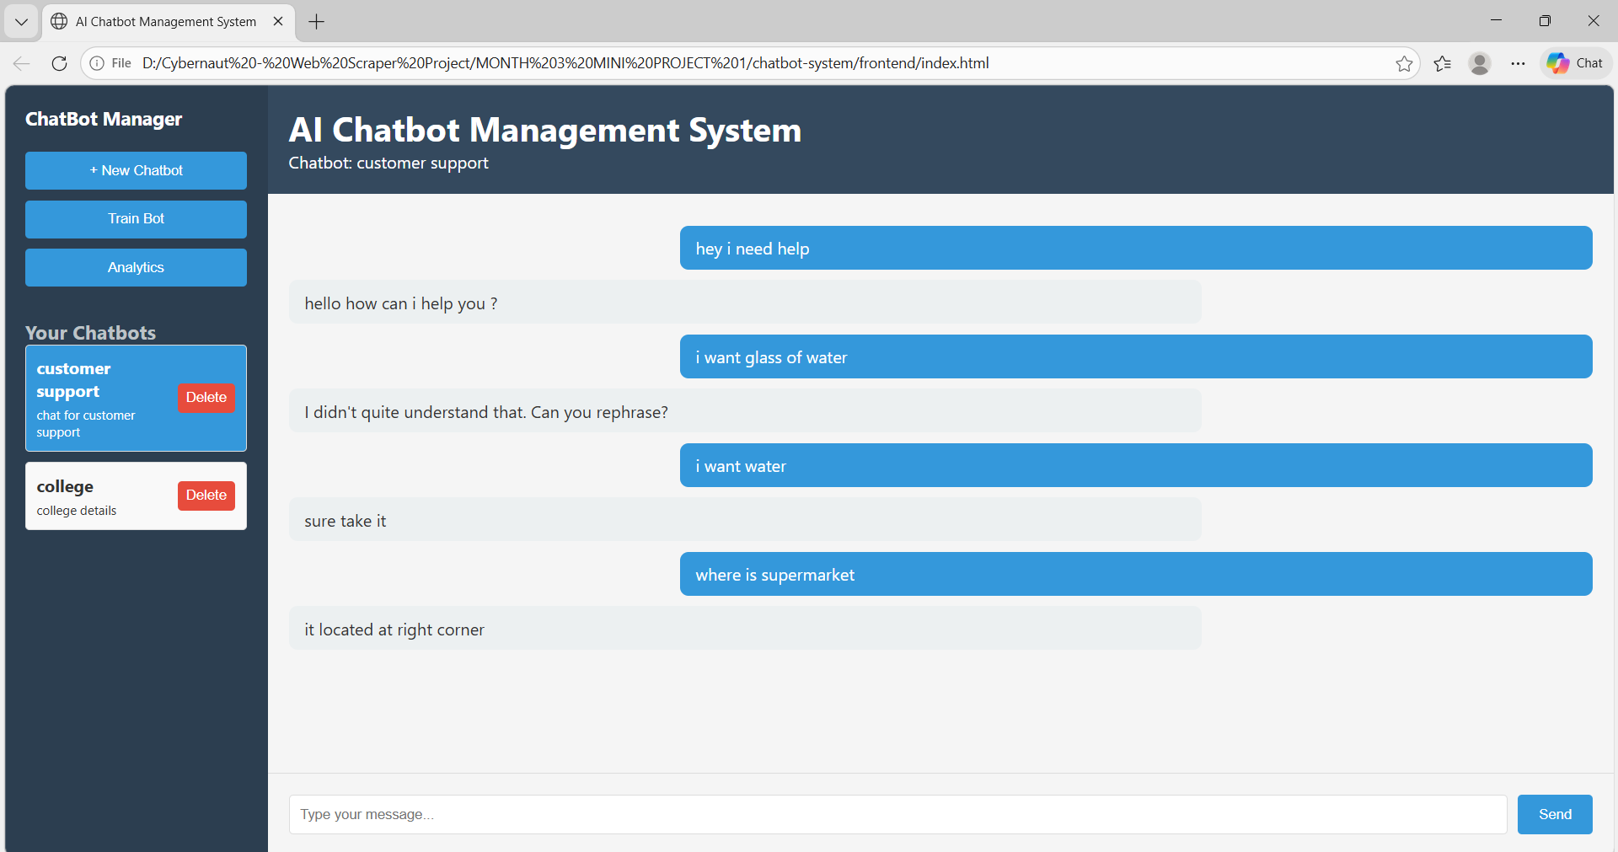

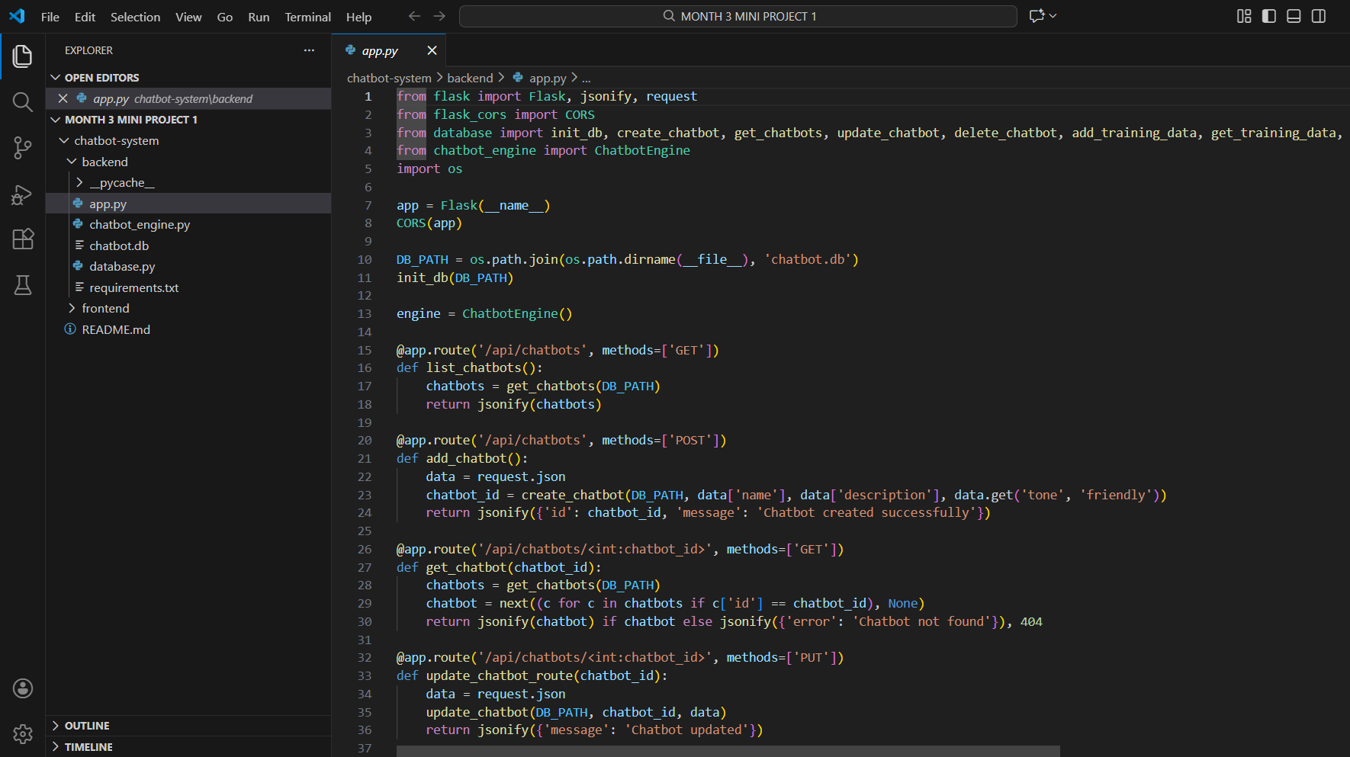

FUTURE ENHANCEMENTS
- Integration with advanced AI models
- Voice-enabled chatbot interaction
- Multi-language support
- Cloud-based deployment
- Advanced analytics and reporting

CONCLUSION
The AI-Based Smart Chatbot Platform provides an efficient and scalable solution for automating user interactions. By combining artificial intelligence concepts with web technologies, the system demonstrates how chatbot management can be simplified while maintaining flexibility and performance. The project serves as a strong foundation for further advancements in intelligent conversational systems.

